Ceramichub - Complete Tile Range Catalogue 2025

1. Glazed Vitrified Tiles
• Product Images (not included in this version)
• Sizes & Thickness: 600x600mm, 800x800mm, 600x1200mm
• Finish Types: Glossy, Matte, Rustic
• Usage Areas: Living Room, Kitchen, Commercial Spaces
• Features: Stain-resistant, Low water absorption, High durability
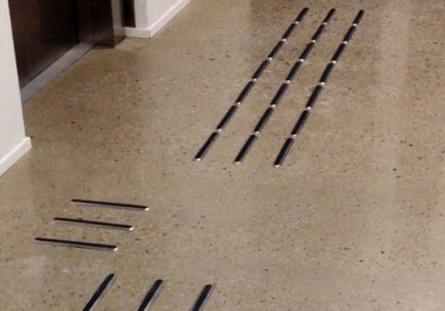

2. Ceramic Tiles
• Product Styles: Wall Tiles, Floor Tiles
• Designs & Patterns: Digital Printed, Stone-look, Wood-look
• Applications: Bathrooms, Kitchens, Outdoor Walls
• Maintenance: Easy to clean, Resistant to mild acids and alkalis
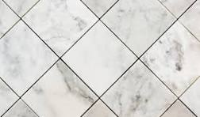

3. Polished Vitrified Tiles
• Finish: High Gloss, Mirror-like Polish
• Applications: Showrooms, Hotels, Luxury Homes
• Resistance: Scratch-resistant, Water-resistant, Long-lasting shine
• Product Specs: 600x600mm, 800x800mm with nano-coating layer


